**DEPARTMENT OF COMPUTER SCIENCE & ENGINEERING**

**THE UNIVERSITY OF TEXAS AT ARLINGTON**

**ARCHITECTURAL DESIGN SPECIFICATION**

**CSE 4316: SENIOR DESIGN I**

**FALL 2015**



**TEAM NAME**

**PRODUCT NAME**

**ALAN TURING**

**GRACE HOPPER**

**JOHN VON NEUMANN**

**ADA LOVELACE**

**CHARLES BABBAGE**



Team Name - Fall 2015 page 1 of 13

**REVISION HISTORY**

|  |  |  |  |
| --- | --- | --- | --- |
| **Revision** | **Date** | **Author(s)** | **Description** |
|  |  |  |  |
| 0.1 | 10.01.2015 | GH | document creation |
|  |  |  |  |
| 0.2 | 10.05.2015 | AT, GH | complete draft |
|  |  |  |  |
| 0.3 | 10.12.2015 | AT, GH | release candidate 1 |
|  |  |  |  |
| 1.0 | 10.20.2015 | AT, GH, CB | official release |
|  |  |  |  |
| 1.1 | 10.31.2015 | AL | added design review requests |
|  |  |  |  |



Team Name - Fall 2015 page 2 of 13

**CONTENTS**

|  |  |  |  |
| --- | --- | --- | --- |
| **1** | **Introduction** | | **5** |
| **2** | **System Overview** | | **6** |
|  | 2.1 | Layer X Description . . . . . . . . . . . . . . . . . . . . . . . . . . . . . . . . . . . . . . . . . . . | 6 |
|  | 2.2 | Layer Y Description . . . . . . . . . . . . . . . . . . . . . . . . . . . . . . . . . . . . . . . . . . . | 6 |
|  | 2.3 | Layer Z Description . . . . . . . . . . . . . . . . . . . . . . . . . . . . . . . . . . . . . . . . . . . | 6 |
| **3** | **Subsystem Definitions & Data Flow** | | **7** |
| **4** | **X Layer Subsystems** | | **8** |
|  | 4.1 | Subsystem 1 . . . . . . . . . . . . . . . . . . . . . . . . . . . . . . . . . . . . . . . . . . . . . . . | 8 |
|  | 4.2 | Subsystem 2 . . . . . . . . . . . . . . . . . . . . . . . . . . . . . . . . . . . . . . . . . . . . . . . | 9 |
|  | 4.3 | Subsystem 3 . . . . . . . . . . . . . . . . . . . . . . . . . . . . . . . . . . . . . . . . . . . . . . . | 9 |
| **5** | **Y Layer Subsystems** | | **10** |
|  | 5.1 | Subsystem 1 . . . . . . . . . . . . . . . . . . . . . . . . . . . . . . . . . . . . . . . . . . . . . . . | 10 |
|  | 5.2 | Subsystem 2 . . . . . . . . . . . . . . . . . . . . . . . . . . . . . . . . . . . . . . . . . . . . . . . | 11 |
|  | 5.3 | Subsystem 3 . . . . . . . . . . . . . . . . . . . . . . . . . . . . . . . . . . . . . . . . . . . . . . . | 11 |
| **6** | **Z Layer Subsystems** | | **12** |
|  | 6.1 | Subsystem 1 . . . . . . . . . . . . . . . . . . . . . . . . . . . . . . . . . . . . . . . . . . . . . . . | 12 |
|  | 6.2 | Subsystem 2 . . . . . . . . . . . . . . . . . . . . . . . . . . . . . . . . . . . . . . . . . . . . . . . | 13 |
|  | 6.3 | Subsystem 3 . . . . . . . . . . . . . . . . . . . . . . . . . . . . . . . . . . . . . . . . . . . . . . . | 13 |



Team Name - Fall 2015 page 3 of 13

**LIST OF FIGURES**

1 A simple architectural layer diagram . . . . . . . . . . . . . . . . . . . . . . . . . . . . . . . . 6

2 A simple data flow diagram . . . . . . . . . . . . . . . . . . . . . . . . . . . . . . . . . . . . . . 7

3 Example subsystem description diagram . . . . . . . . . . . . . . . . . . . . . . . . . . . . . . 8

4 Example subsystem description diagram . . . . . . . . . . . . . . . . . . . . . . . . . . . . . . 10

5 Example subsystem description diagram . . . . . . . . . . . . . . . . . . . . . . . . . . . . . . 12

**LIST OF TABLES**

2 Subsystem interfaces . . . . . . . . . . . . . . . . . . . . . . . . . . . . . . . . . . . . . . . . . . 9

3 Subsystem interfaces . . . . . . . . . . . . . . . . . . . . . . . . . . . . . . . . . . . . . . . . . . 11

4 Subsystem interfaces . . . . . . . . . . . . . . . . . . . . . . . . . . . . . . . . . . . . . . . . . . 13



Team Name - Fall 2015 page 4 of 13

* **INTRODUCTION**

Fermentation is an important process of brewing beer. Key part of brewing beer with a certain taste and density requires fermenting beer at the right temperature for a certain period of time. For home-brewers, it can be tedious to keep track of temperature and density of beer during the fermentation process.

"Bluetooth Hydrometer" is a device designed to help home-brewers keep track of temperature and density of beer during the fermentation process. It floats on the beer inside the fermenting vessel while sending data to a smartphone via Bluetooth.

Bluetooth Hydrometer consists Arduino-nano with 9-axis inertial measurement unit (IMU) and temperature sensor. Temperature sensor reads temperature while IMU reads relative position when the device is floating. Arduino gets analog input from sensors and process data to get actual temperature and specific gravity of beer. Specific gravity is obtained from relative position of hydrometer inside the fermentation vessel. Once the process is done, data are sent to a smartphone via Bluetooth.

Temperature and density data are stored in a database for future reference and analysis. Mobile app provides visual interface to home-brewers at real time providing current temperature and specific gravity of beer.



Team Name - Fall 2015 page 5 of 13

* **SYSTEM OVERVIEW**

Overall system consists of three major layers, Sensors, Controllers (Hardware/Software) and UI/UX. Each layers has separate functions and interface with each other for data input and output. Sensors layer provide analog data to Controllers for further processing. After analyzing datas from sensors, Controllers provide digital datas to UI/UX for providing relevant information to user with good visual interface.

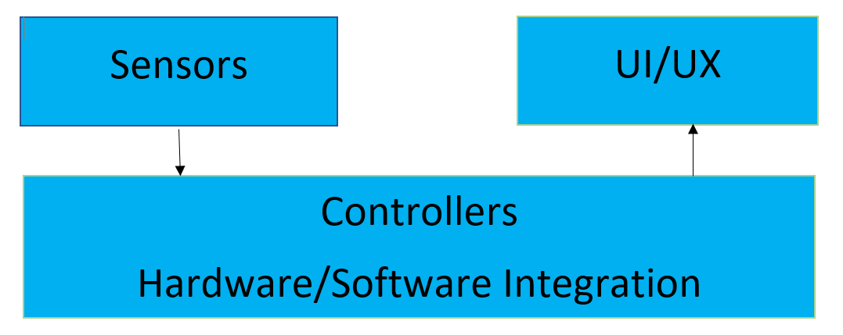

Figure 1: A simple architectural layer diagram

**2.1 Sensors**

Sensors layer for Bluetooth Hydrometer device mainly consits of two sensors, temperature sensor and 9-axis IMU sensor. Sensors are essential parts of Bluetooth Hydrometer which measure temperature and specific gravity of beer; which are the main requirements of the project. Temperature sensor provides analog temeperature read whereas, IMU provides relative position of Bluetooth Hydrometer during floatation. Temperature data and position data are read by Arduino nano in Controllers layer. Sensors, therefore provides necessary input data to Controllers.

**2.2 Controllers**

Aurduino nano 33 BLE is the heart of Bluetooth Hydrometer device. Nano is low-powered bluetooth enabled microcontroller which can read analog as well as digital inputs from sensors. Sensors provide critical analog datas for temperature and relative postion of hydrometer. Nano then process analog datas and provides actual temperature and specific gravity (depending on relative position) to UI/UX.

Nano is programmed to handle analog data from sensors and provide output to UI/UX layer.



**2.3 UI/UX**

UI/UX is another important layer that provides user interface to user by providing actual data. Temperature and specific gravity data are visually and graphically presented to user through a mobile app or through a website. Datas from Controller are stored in a database and are analyzed through a software.

Team Name - Fall 2015 page 6 of 13

* **SUBSYSTEM DEFINITIONS & DATA FLOW**

This section breaks down your layer abstraction to another level of detail. Here you grapically repre-sent the logical subsytems that compose each layer and show the interactions/interfaces between those subsystems. A subsystem can be thought of as a programming unit that implements one of the major functions of the layer. It, therefore, has data elements that serve as source/sinks for other subsystems. The logical data elements that flow between subsystems need to be explicitly defined at this point, beginning with a data flow-like diagram based on the block diagram.

Figure 2: A simple data flow diagram



Team Name - Fall 2015 page 7 of 13

* **Sensors**

**4.1 Temperature Sensor**

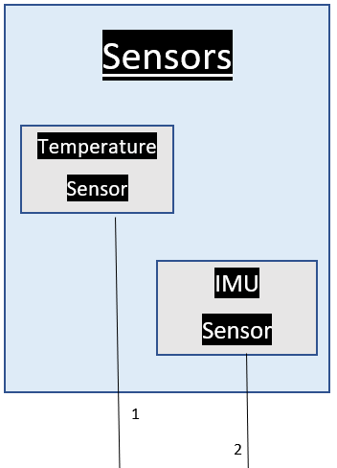

Figure 2: Sensor subsystems description

Figure 3: Example subsystem description diagram

**4.1.1 ASSUMPTIONS**

Temperature sensors are basically conducting metal having some resistance which can measure temperature in the form of electronic signal. Temperature sensor used in hydrometer has an accuracy of +- 1.5 degree C.

**4.1.2 RESPONSIBILITIES**

It stores temperature in the form of electronic signal and changes whenever the temperature changes.Temperature sensors only one function is to send the analog data of temperature to Arduino nano.

**4.1.3 Temperature sensor INTERFACES**



Team Name - Fall 2015 page 8 of 13

Table 2: Subsystem interfaces

|  |  |  |  |
| --- | --- | --- | --- |
| ID | Description | Inputs | Outputs |
|  |  |  |  |
|  | Temperature interface | N/A | output 1 |
|  |  |  |  |
|  |  |  |  |

**4.2 IMU Sensor**



**4.2.1 Assumptions**

**4.2.2 Responsibilities**

Arduino nano 33 BLE is an advance microcontroller, it consists of 9-axis Inertial Measurement Unit (IMU) which refers to built in gyroscope, accelerometer and magnetometer.

While floating, IMU send data to nano about it’s position which is the primary function of IMU sensor.

Repeat for each subsystem



**4.2.3 IMU Interfaces**

|  |  |  |  |
| --- | --- | --- | --- |
| ID | Description | Inputs | Outputs |
|  |  |  |  |
|  | IMU Interface | N/A | output 2 |
|  |  |  |  |
|  |  |  |  |

Team Name - Fall 2015 page 9 of 13

* **Controller SUBSYSTEMS**

**5.1 Arduino Nano 33 BLE**

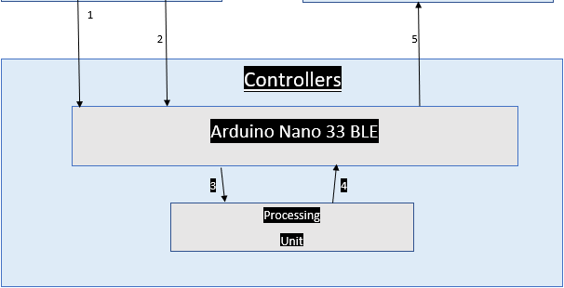

Figure 4: Example subsystem description diagram

**5.1.1 ASSUMPTIONS**

Not applicable

**5.1.2 RESPONSIBILITIES**

The main responsibility of Arduino nano is to receive anlog signals from temperature sensor and IMU sensore. CPU inside then process analog data then transfers process data to UI/UX layer via bluetooth.

**5.1.3 SUBSYSTEM INTERFACES**



Team Name - Fall 2015 page 10 of 13

data elements will pass through this interface.

Table 3: Subsystem interfaces

|  |  |  |  |
| --- | --- | --- | --- |
| ID | Description | Inputs | Outputs |
|  |  |  |  |
|  | Controller interface | input 1 | output 5 |
|  |  | Input 2  Input 4 |  |
|  |  |  |  |

**5.2 Processing Unit**





**5.2.1 Assumptions**

Hydrometer is always turned on whenever it’s inside the fermentation vessel. Since, position of hydrometer is needed for specific gravity, it’s assumed that the hydrometer is floating.

**5.2.2 Responsiblities**

60 MHz CPU is responsible for processing temperature and specific gravity data, that it receives from sensors attached to Arduino nano. Arduino nano is programmed to handle those data whenever nano is turned on. It outputs the accurate temperature and specific gravity data after processing.

**5.2.3. Processing Unit Interface**

|  |  |  |  |
| --- | --- | --- | --- |
| ID | Description | Inputs | Outputs |
|  |  |  |  |
|  | Processing Unit Interface | Input 3 | output 4 |
|  |  |  |  |
|  |  |  |  |

Team Name - Fall 2015 page 11 of 13

* **Z LAYER SUBSYSTEMS**

In this section, the layer is described in some detail in terms of its specific subsystems. Describe each of the layers and its subsystems in a separate chapter/major subsection of this document. The content of each subsystem description should be similar. Include in this section any special considerations and/or trade-offs considered for the approach you have chosen.

**6.1 SUBSYSTEM 1**

This section should be a general description of a particular subsystem for the given layer. For most subsystems, an extract of the architectural block diagram with data flows is useful. This should consist of the subsystem being described and those subsystems with which it communicates.

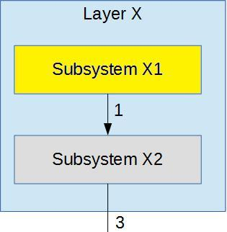

Figure 5: Example subsystem description diagram

**6.1.1 ASSUMPTIONS**

Any assumptions made in the definition of the subsystem should be listed and described. Pay particular attention to assumptions concerning interfaces and interactions with other layers.

**6.1.2 RESPONSIBILITIES**

Each of the responsibilities/features/functions/services of the subsystem as identified in the architec-tural summary must be expanded to more detailed responsibilities. These responsibilities form the basis for the identification of the finer-grained responsibilities of the layer’s internal subsystems. Clearly de-scribe what each subsystem does.

**6.1.3 SUBSYSTEM INTERFACES**

Each of the inputs and outputs for the subsystem are defined here. Create a table with an entry for each labelled interface that connects to this subsystem. For each entry, describe any incoming and outgoing



Team Name - Fall 2015 page 12 of 13

data elements will pass through this interface.

Table 4: Subsystem interfaces

|  |  |  |  |
| --- | --- | --- | --- |
| ID | Description | Inputs | Outputs |
|  |  |  |  |
| #xx | Description of the interface/bus | input 1 | output 1 |
| input 2 |
|  |  |  |
| #xx | Description of the interface/bus | N/A | output 1 |

**6.2 SUBSYSTEM 2**

Repeat for each subsystem

**6.3 SUBSYSTEM 3**

Repeat for each subsystem



Team Name - Fall 2015 page 13 of 13